Faculty Profile
Sr.  No. | Details
1 | Name of faculty : | Ms.Vrushali Manikrao Bodhankar |  |  | Pho  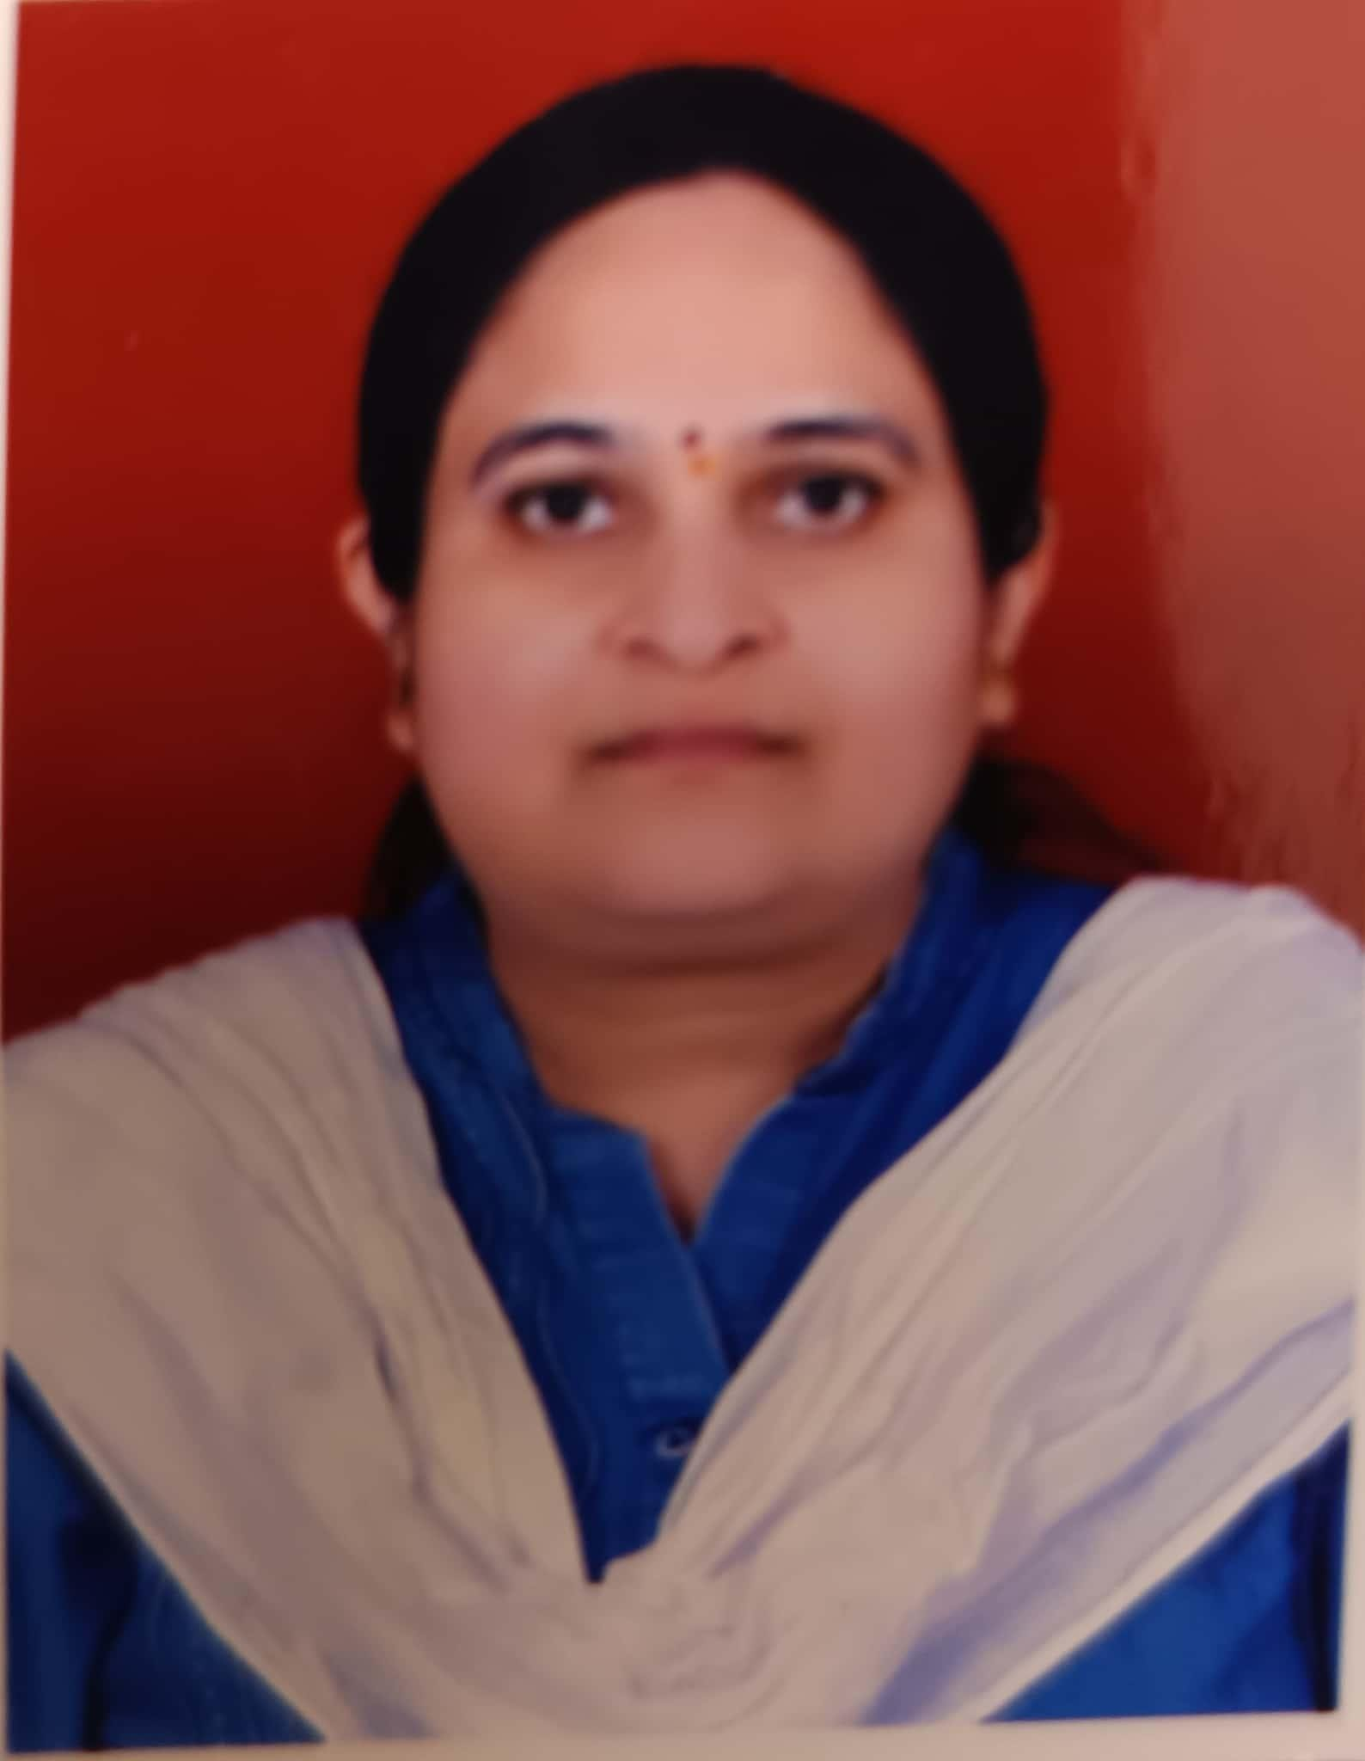  tograph
2 | Designation : | Assistant Professor
3 | Contact Details : | 9689184745
4 | Email ID : | vrushali.bodhankar@abmspcoerpune.org
5 | Academic Qualification : | Qualification | Year of Passing | University |  | Class
5 | Academic Qualification : | B.E. / B.Tech | 2006 | S.R.T.M.U.Nanded |  | First Class With Distinction
5 | Academic Qualification : | M.E. /  M.Tech | 2020 | B.A.M.U.Aurangabad |  | First Class
5 | Academic Qualification : | Ph.D.
5 | Academic Qualification : | Other
6 | Work Experience Details : | Teaching : 12 Years _6_ Months Industry : -_ Years  Months
7 | No of Publication / Presentation :
7 | a. In International Journals | 2
7 | b. In National Journals
7 | c. In International conference
7 | d. In National conference

8 | Area of interest/specialization  : | Network Security
9 | Any other information :
 | (PhD supervisor / PG
 | approved Teacher/
 | Representation on other
 | Academic Body)
 | (If any)
10 | Awards & Achievements : | Two NPTEL Certifications.

