Faculty Profile
Sr. No. |  | Details
1 | Name of faculty : | Prof. Varsha Prashant Chavan |  |  | 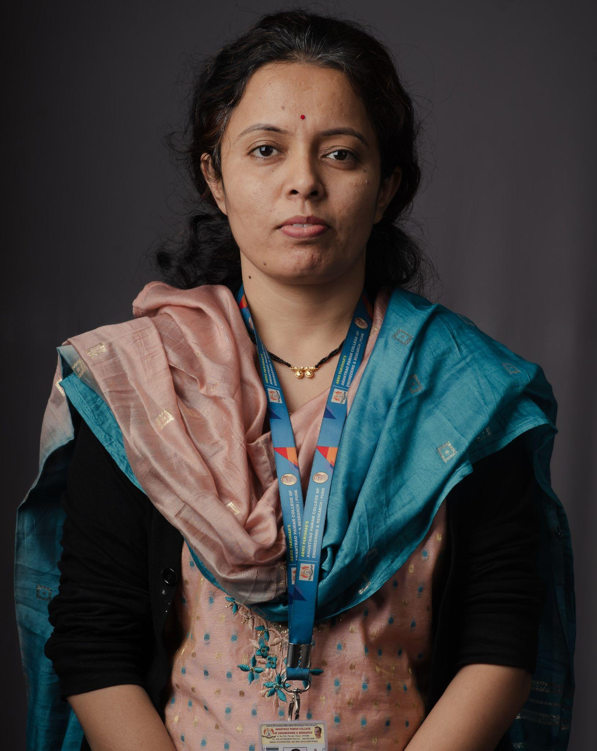
2 | Designation : | Assistant Professor
3 | Contact Details : | 8411939236
4 | Email ID : | varsha.chavan@abmspcoerpune.org
 |  | Qualification | Year of Passing | University |  | Class
 |  | B.E. / B.Tech | 2011 | SPPU |  | First Class
5 | Academic Qualification : | M.E. / M.Tech | 2015 | SPPU |  | First Class
 |  | Ph.D. | Pursuing | Bharati Vidyapeeth Pune |  | -
 |  | Other
6 | Work Experience Details : | Teaching : 6 Years Industry : 5 Years
 | No of Publication / Presentation : | 5
 | a. In International Journals | -
7 | b. In National Journals | 2
 | c. In International conference | 1
 | d. In National conference | 2
8 | Area of interest/specialization : | Cloud Computing, DevOps, Machine Learning, Artificial Intelligence
 | Any other information :
9 | (PhD supervisor / PG approved Teacher/ Representation on other Academic Body) | • Departmental NBA Coordinator  • Departmental SPPU Exam Coordinator  • Departmental ISO certified Auditor  • Departmental AMC Coordinator  • Departmental Alumni Coordinator  • Departmental DAB PAC coordinator
 | (If any)
10 | Awards & Achievements : | - NPTEL – Artificial Intelligence and techniques completed  - ISO 21001:2018 Certified Internal Auditor.  - Completed Diploma in Software Engineering from SEED Infotech Pune.  - Worked as a member of the Syllabus Revision Committee for the TE Machine Learning subject.  - Deliver a session on Machine Learning Unit-III Faculty Orientation Program of TE AI&DS 2024 pattern syllabus.  - Worked as a paper reviewer in a conference.

