Faculty Profile
Sr.  No. | Details
1 | Name of faculty : | Prof. Tejal R. Vallakathi |  |  | 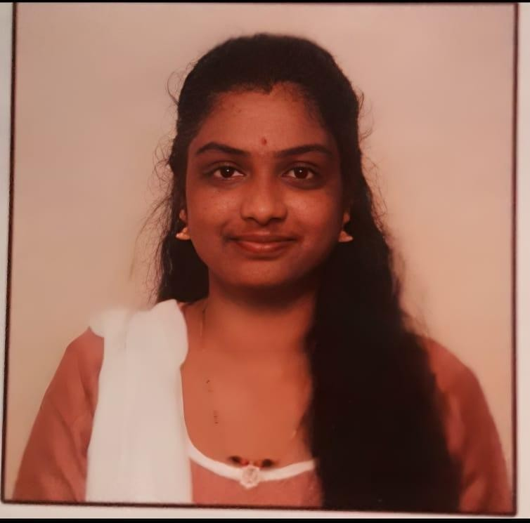  Photograph
2 | Designation : | Assistant Professor
3 | Contact Details : | 9139458046
4 | Email ID : | tejal.vallakathi@abmspcoerpune.org
5 | Academic Qualification : | Qualificatio  n | Year of Passing | University |  | Class
5 | Academic Qualification : | B.E. / B.Tech | 2017 | SPPU |  | First Class
5 | Academic Qualification : | M.E. /  M.Tech | 2023 | SPPU |  | First class with Distinction
5 | Academic Qualification : | Ph.D. | Pursuing | Pimpary Chinchwad university |  | -
5 | Academic Qualification : | Other
6 | Work Experience Details : | Teaching : 5 Years Industry :1 Years , 5 Months
7 | No of Publication / Presentation :
7 | a. In International Journals | 2
7 | b. In National Journals | -
7 | c. In International conference | -
7 | d. In National conference | -
8 | Area of interest/specialization : | Android Application Development, Programming, Testing, AI
9 | Any other information : | 1.5 year experience as Android Application Development

(PhD supervisor / PG approved Teacher/ Representation on other Academic Body)
(If any)
10 | Awards & Achievements :

