Faculty Profile
Sr. No. |  | Details
1 | Name of faculty : | Prof. Rita Balu Salve |  |  | Photograph 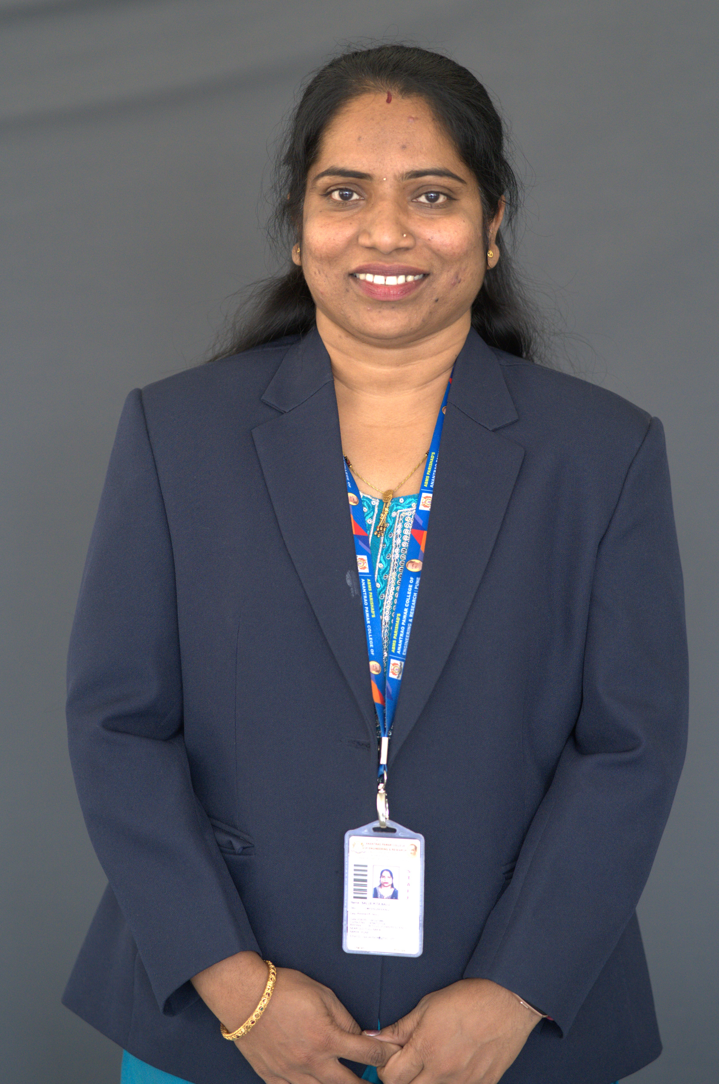
2 | Designation : | Assistant Professor
3 | Contact Details : | 9766701109
4 | Email ID : | rita.salve@abmspcoerpune.org
 |  | Qualification | Year of Passing | University |  | Class
 |  | B.E. | 2008 | Shivaji University |  | 65.92%
5 | Academic Qualification : | M.Tech | 2014 | JNTU |  | 81.88%
 |  | Ph.D. | -- | -- |  | --
 |  | Other | -- | -- |  | --
6 | Work Experience Details : | Teaching : 5 Years 8 Months Industry : 4 Years 5 Months
 | No of Publication / Presentation :
 | a. In International Journals | --
7 | b. In National Journals | --
 | c. In International conference | 01
 | d. In National conference | --
8 | Area of interest/specialization | Software Testing and Service now, Cloud computing
 | Any other information : | --
9 | (PhD supervisor / PG approved Teacher/ Representation on other Academic Body) | --
 | (If any)
10 | Awards & Achievements : | - Copyright registered for ENGILERAN, Student performance tracking and improvement system.  - Copyright registered for Star Alumni - Bridge between faculty and students.

