Faculty Profile
Sr. No. |  | Details
1 | Name of faculty : | Prof. Pournima Watharkar |  |  | Photograph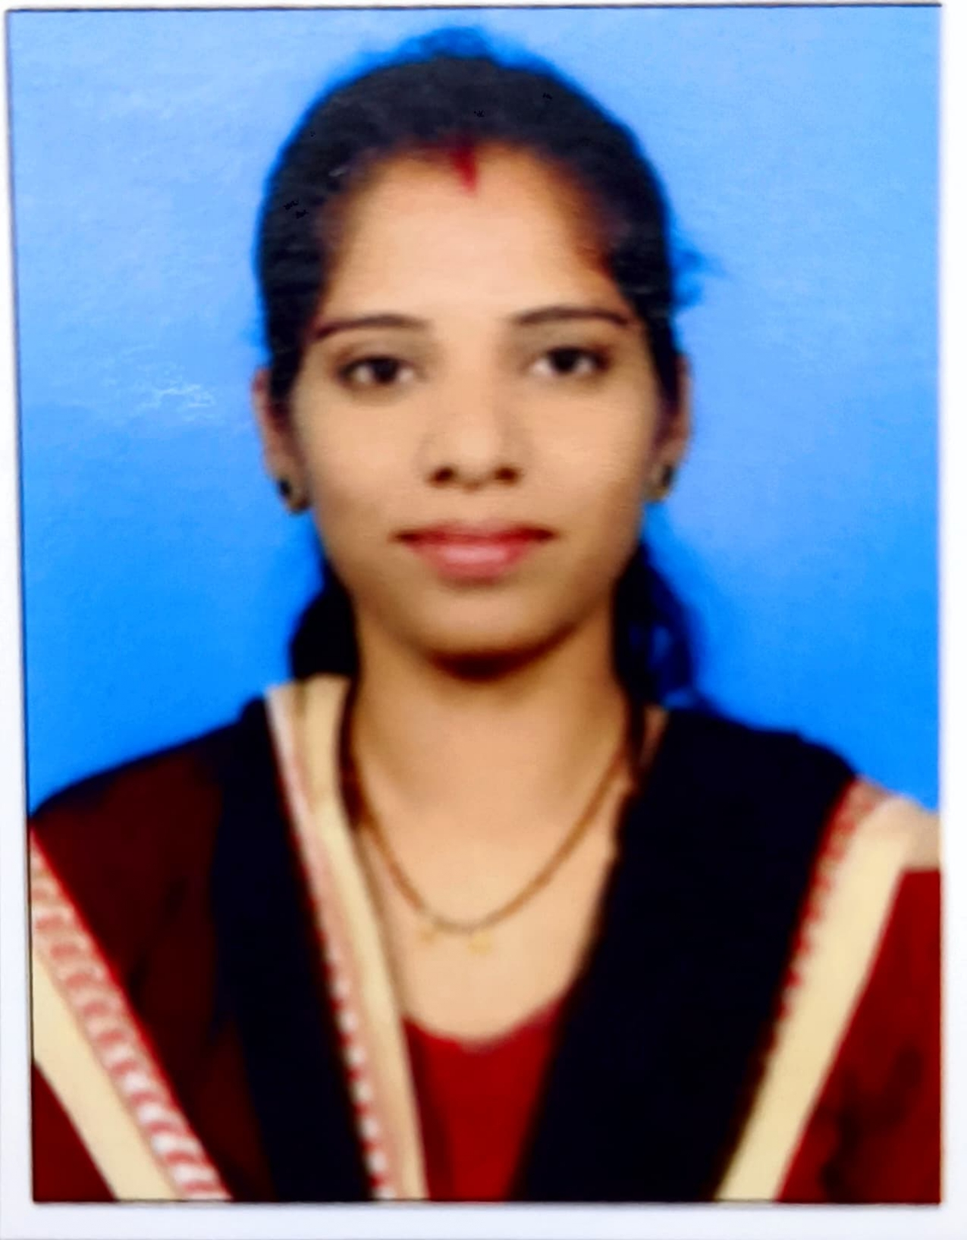
2 | Designation : | Assistant Professor
3 | Contact Details : | 9130465297
4 | Email ID : | Pournima.watharkar@abmspcoerpune.org
 |  | Qualification | Year of Passing | University |  | Class
 |  | B.E. / B.Tech | 2016 | Shivaji University Kolhapur. MH |  | 1st
5 | Academic Qualification : | M.E. / M.Tech | 2018 | Shivaji University Kolhapur. MH |  | 1st
 |  | Ph.D. | -
 |  | Other | -
6 | Work Experience Details : | Teaching : 1 Years 6 Months Industry : 2 Years 3 Months
 | No of Publication / Presentation : | -
 | a. In International Journals | -
7 | b. In National Journals | -
 | c. In International conference | -
 | d. In National conference | -
8 | Area of interest/specialization : | Cloud Computing, Deep Leaning
 | Any other information :
9 | (PhD supervisor / PG approved Teacher/ Representation on other Academic Body) | -
 | (If any)
10 | Awards & Achievements : | -

