Faculty Profile
Sr. No. |  | Details
1 | Name of faculty : | Prof. Poonam Sunil Jadhavar |  |  | 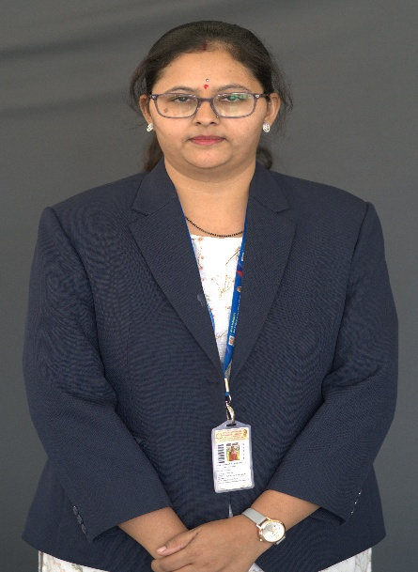
2 | Designation : | Assistant Professor
3 | Contact Details : | 7972961949
4 | Email ID : | poonam.jadhavar@abmspcoerpune.org
 |  | Qualification | Year of Passing | University |  | Class
 |  | B.E. | 2014 | Shivaji University |  | First Class with Distinction
5 | Academic Qualification : | M.E. | 2020 | SPPU |  | First Class
 |  | Ph.D.
 |  | Other
6 | Work Experience Details : | Teaching : 06 Years 06 Months Industry : 01 Years
 | No of Publication / Presentation : | 12
 | a. In International Journals | -
7 | b. In National Journals | 09
 | c. In International conference | 02
 | d. In National conference | 01
8 | Area of interest/specialization : | Data Mining,AI,ML
 | Any other information :
9 | (PhD supervisor / PG approved Teacher/ Representation on other Academic Body)
 | (If any)
10 | Awards & Achievements : | 1.Awarded NPTEL ELITE Certification NBA Accreditation and Teaching and learning in Engineering (NATE)  2.Awarded NPTEL ELITE Certification Cloud Computing

