Faculty Profile
Sr. No. |  | Details
1 | Name of faculty : | Prof. Mangal Vitthal Wagh |  |  | 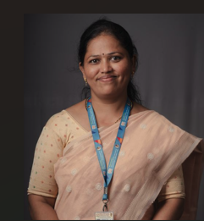
2 | Designation : | Assistant Professor
3 | Contact Details : | 9112350289
4 | Email ID : | mangal.wagh@abmspcoerpune.org
 |  | Qualification | Year of Passing | University |  | Class
 |  | B.E. / B.Tech | 2016 | SPPU |  | First Class
5 | Academic Qualification : | M.E. / M.Tech | 2020 | SPPU |  | Distinction
 |  | Ph.D. | - | - |  | -
 |  | Other | - | - |  | -
6 | Work Experience Details : | Teaching : 4 Years Industry : -
 | No of Publication / Presentation : | 8
 | a. In International Journals | 6
7 | b. In National Journals | 2
 | c. In International conference | 2
 | d. In National conference | 2
8 | Area of interest/specialization : | Cloud Computing, DevOps, Machine Learning, Artificial Intelligence, Data Mining
 | Any other information :
9 | (PhD supervisor / PG approved Teacher/ Representation on other Academic Body) | - Departmental NBA Criteria-3 Coordinator  - Departmental NAAC Criteria-2 Coordinator  - Departmental Parent Teacher Coordinator  - Departmental IIT Bombay Spoken Tutorial Coordinator  - Departmental IIT Bombay Virtual Lab Coordinator  - Departmental Course Exit Survey Coordinator  - Project Coordinator  - B.E Class Teacher
 | (If any)
10 | Awards & Achievements : | - NPTEL –Problem solving & searching methods by using AI course completed.  - Appreciation Letter from IIT Bombay Spoken Tutorial Coordinator for A.Y 2024-25 & 2025-26.

