Faculty Profile

Sr.  No. | Details
1 | Name of faculty : | Dipali Karbhari Pawar |  |  | 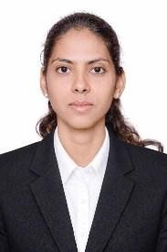
2 | Designation : | Assistant Professor
3 | Contact Details : | 8275170556
4 | Email ID : | dipali.pawar@abmspcoerpune.org
5 | Academic Qualification : | Qualification | Year of Passing | University |  | Class
5 | Academic Qualification : | B.E. / B.Tech | 2016 | SPPU |  | First Class with Distinction
5 | Academic Qualification : | M.E. /  M.Tech | 2019 | SPPU |  | First Class with Distinction
5 | Academic Qualification : | Ph.D. | Pursuing | COEP  Technological University, Pune
5 | Academic Qualification : | Other
6 | Work Experience Details : | Teaching : 2 Years 6 Months Industry : Years Months
7 | No of Publication / Presentation :
7 | a. In International Journals | 12
7 | b. In National Journals
7 | c. In International conference
7 | d. In National conference
8 | Area of interest/specialization : | DBMS, Machine Learning, Natural Language Processing
9 | Any other information :
9 | (PhD supervisor / PG approved  Teacher/ Representation on other Academic Body)
9 | (If any)
10 | Awards & Achievements :

