Faculty Profile
Sr. No. |  | Details
1 | Name of faculty : | Asmeet Bhosale |  |  | 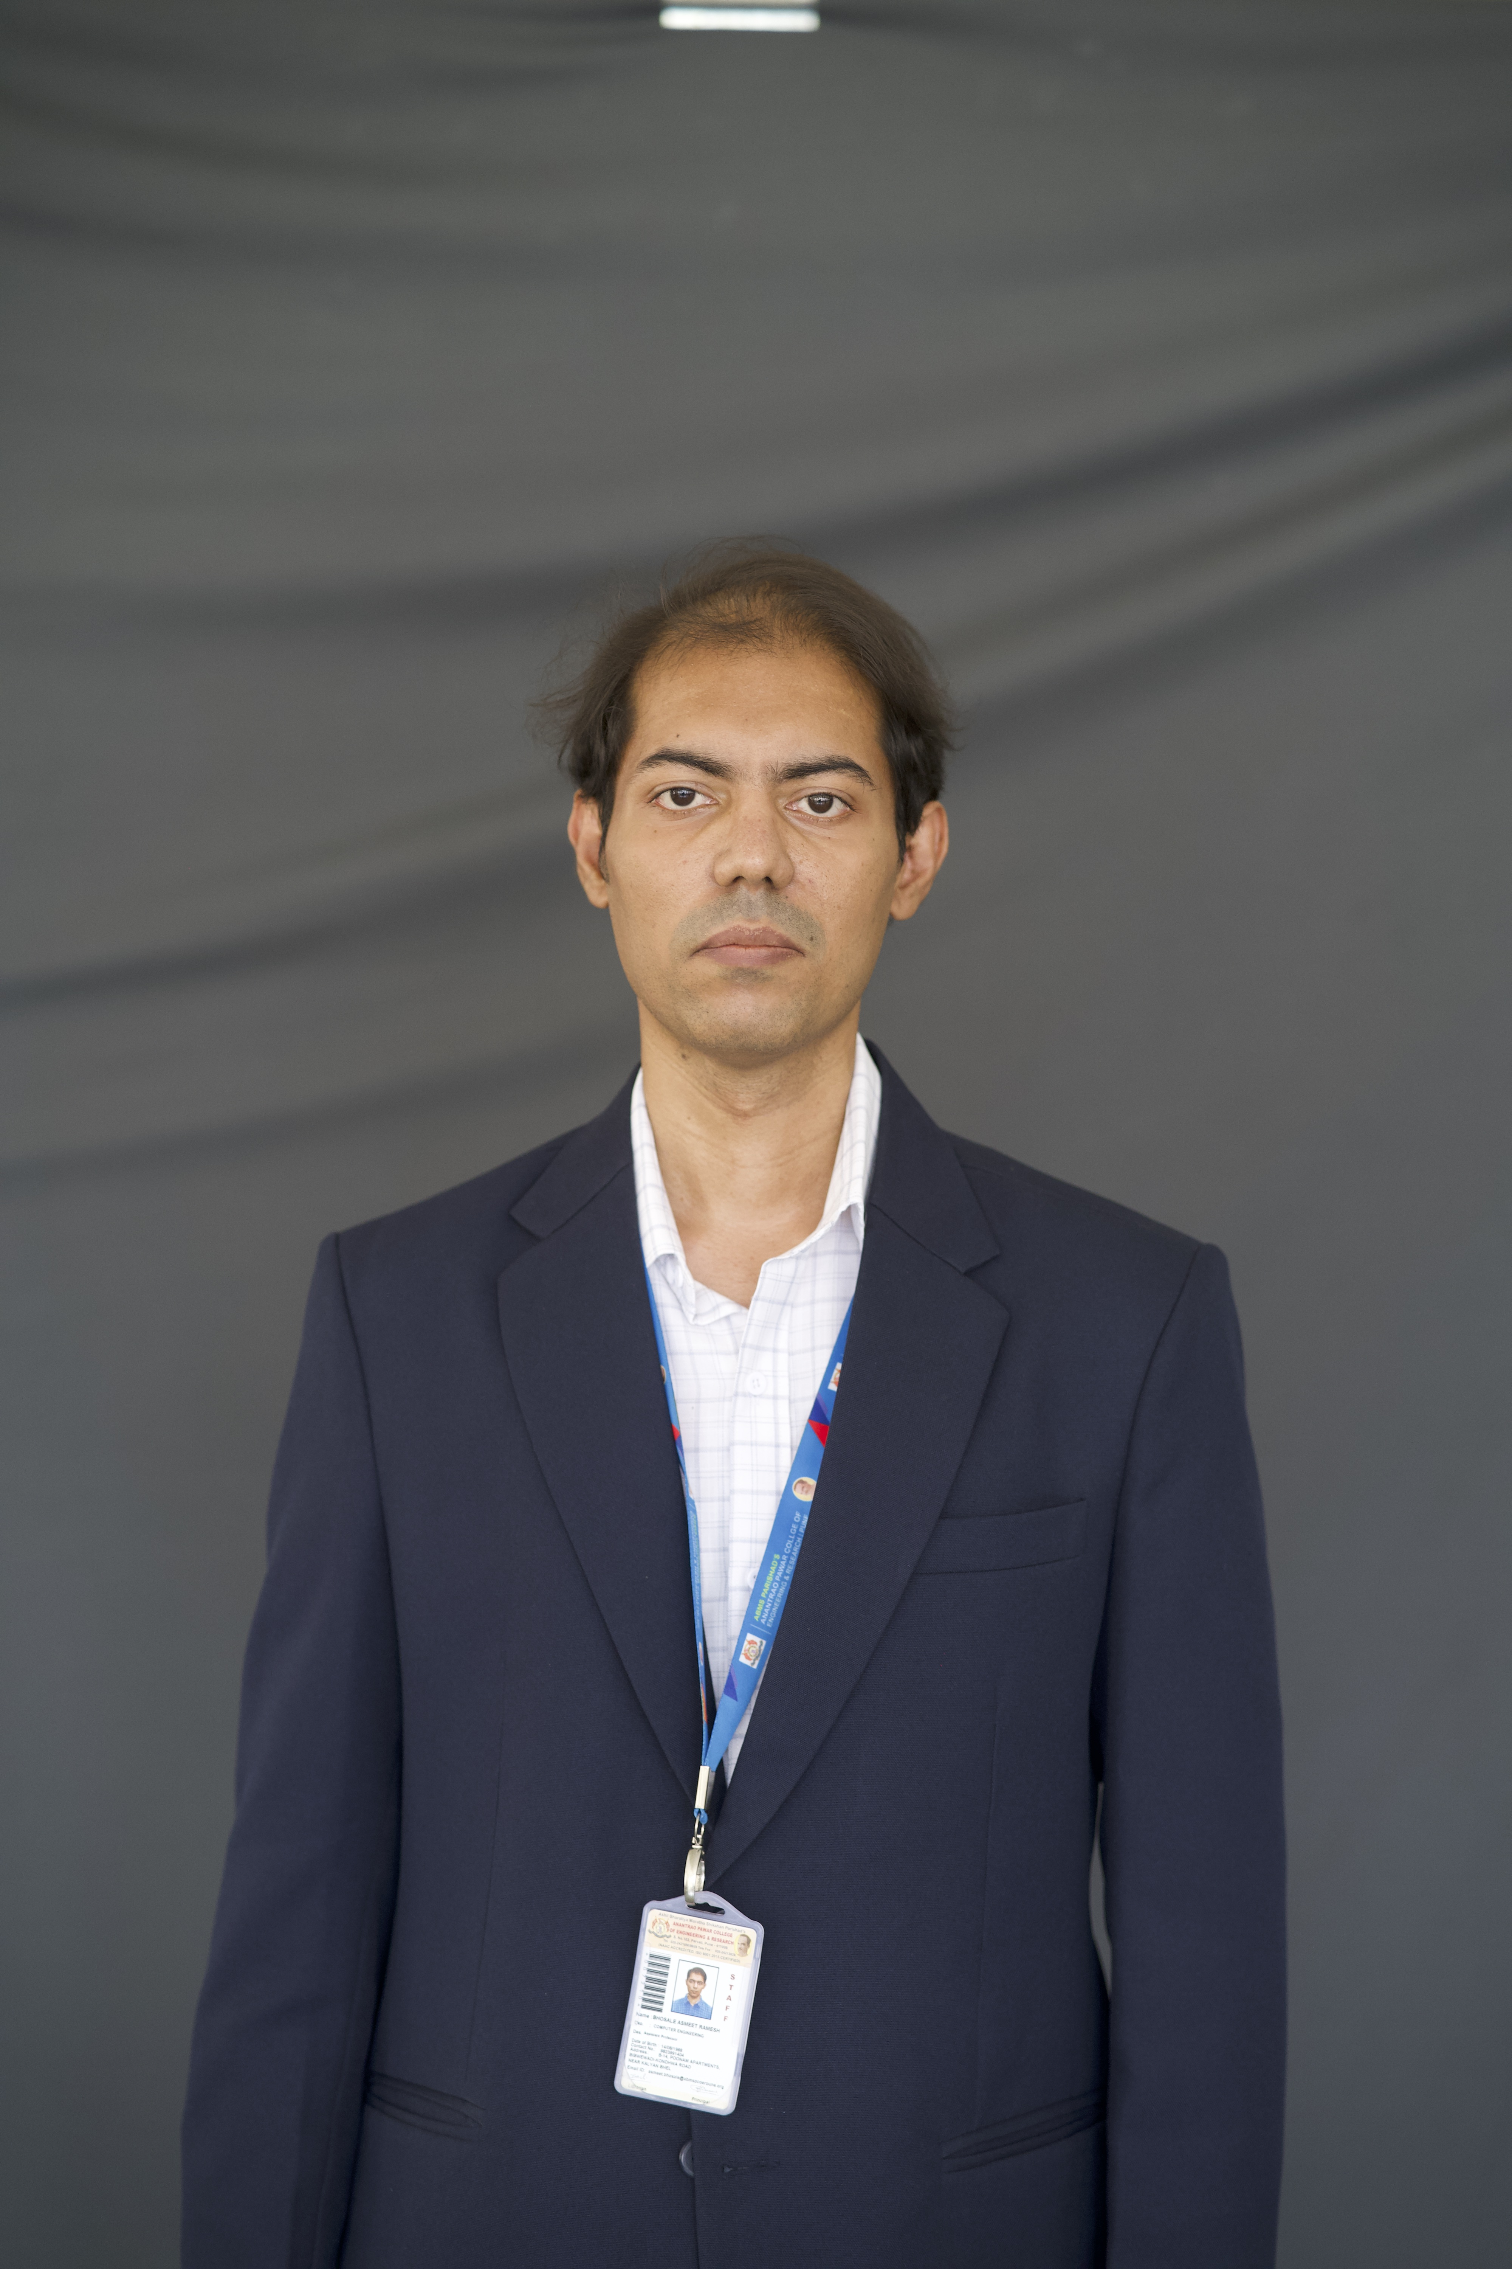
2 | Designation : | Assistant Professor
3 | Contact Details : | 9823991404
4 | Email ID : | asmeet.bhosale@abmspcoerpune.org
 |  | Qualification | Year of Passing | University |  | Class
 |  | B.E. / B.Tech | 2010 | Savitribai Phule Pune University |  | Higher Second Class
5 | Academic Qualification : | M.E. / M.Tech | 2015 | Savitribai Phule Pune University |  | First Class
 |  | Ph.D. | - | - |  | -
 |  | Other | - | - |  | -
6 | Work Experience Details : | Teaching : 0 Years 11 Months Industry : 5 Years 7 Months
 | No of Publication / Presentation : | -
 | a. In International Journals | -
7 | b. In National Journals | -
 | c. In International conference | -
 | d. In National conference | -
8 | Area of interest/specialization : | Computer Engineering
 | Any other information :
9 | (PhD supervisor / PG approved Teacher/ Representation on other Academic Body)
 | (If any)
10 | Awards & Achievements :

