Faculty Profile
Sr. No. |  | Details
1 | Name of faculty : | Amol Bhadange |  |  | 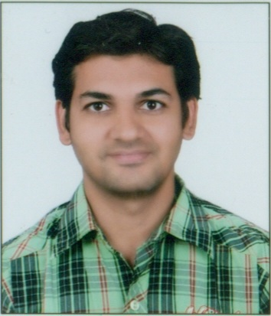
2 | Designation : | Assistant Professor
3 | Contact Details : | 9763355997
4 | Email ID : | amol.bhadange@abmspcoerpune.org
 |  | Qualification | Year of Passing | University |  | Class
 |  | B.E. / B.Tech | 2004 | SPPU |  | Second  Class
5 | Academic Qualification : | M.E. / M.Tech | 2015 | SPPU |  | First  Class
 |  | Ph.D. | - | - |  | -
 |  | Other | - | - |  | -
6 | Work Experience Details : | Teaching : 1 Years Months Industry :- - Years - Months
 | No of Publication / Presentation : | Publication
 | a. In International Journals | -
7 | b. In National Journals | -
 | c. In International conference | 1
 | d. In National conference | -
8 | Area of interest/specialization : | Software Engineering, Machine Learning
 | Any other information :
9 | (PhD supervisor / PG approved Teacher/ Representation on other Academic Body) | -
 | (If any)
10 | Awards & Achievements : | 1.Patent Grant Published  2.Awarded NPTEL ELITE Certification Software Testing

