Faculty Profile
Sr. No. |  | Details
1 | Name of faculty : | Prof.Akanksha Achyut Godage |  |  | 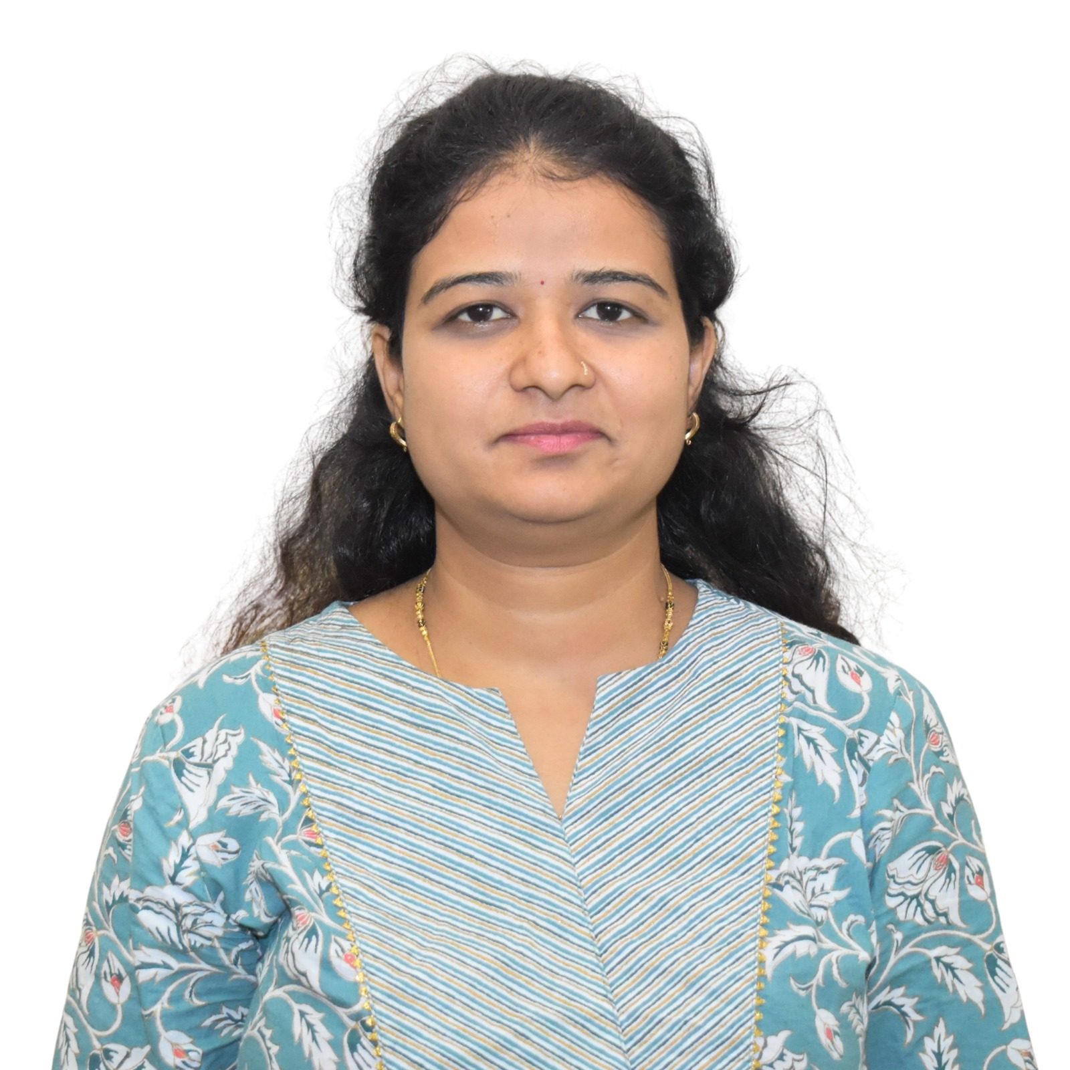
2 | Designation : | Assistant Professor, AI&DS, APCOER
3 | Contact Details : | 8660768615
4 | Email ID : | akanksha.@abmspcoerpune.
 |  | Qualification | Year of Passing | University |  | Class
 |  | B.E. / B.Tech | 2014 | Savitribai Phule Pune University |  | First Class with Distinction
5 | Academic Qualification : | M.E. / M.Tech | 2017 | Jawaharlal Nehru Technological University Hyderabad |  | First Class with Distinction
6 | Work Experience Details : | Teaching : 2 Years
 | No of Publication / Presentation : | 0
 | a. In International Journals | 0
7 | b. In National Journals | 0
 | c. In International conference | 0
 | d. In National conference | 0
8 | Area of interest/specialization : | Deep Learning, Machine Learning, Artificial Intelligence
 | Any other information :
9 | (PhD supervisor / PG approved Teacher/ Representation on other Academic Body) | Representation on Other Academic Body-Yes – Departmental and Institutional Academic/Administrative Representation, including:  • Departmental ISO Coordinator & Internal Auditor  • First Year Admission Coordinator
10 | Awards & Achievements :

