Faculty Profile
Sr. No. |  | Details
1 | Name of faculty : | Prof. Amol R. Naikoji |  |  | 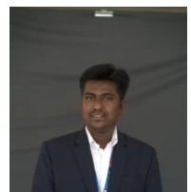
2 | Designation : | Assistant Professor
3 | Contact Details : | 9511700748
4 | Email ID : | amol.naikoji@abmspcoerpune.org
 |  | Qualification | Year of Passing | University |  | Class
 |  | B.E. / B.Tech | 2015 | SPPU |  | First Class
5 | Academic Qualification : | M.E. / M.Tech | 2023 | SPPU |  | First Class With Distinction
 |  | Ph.D.
 |  | Other
6 | Work Experience Details : | Teaching : _3____ Years _3_ Months Industry :___NIL__ Years _____ Months
 | No of Publication / Presentation : | 5
 | a. In International Journals | -
7 | b. In National Journals | 2
 | c. In International conference | 1
 | d. In National conference | 2
8 | Area of interest/specialization : | Network & Security , Cyber Security
 | Any other information :
9 | (PhD supervisor / PG approved Teacher/ Representation on other Academic Body)
 | (If any)
10 | Awards & Achievements :

