|  |
| --- |
| AKHIL BHARTIYA MARATHA SHIKSHAN PARISHAD’S  **Anantrao Pawar College Of Engineering & Research**  Sr. No. 103, Shahu College Campus, Parvati, Pune – 411009  ***Accredited by NAAC***  **Record No.:** ADM/D/013C **DoI: 2/01/2023 Revision: 00** |
| **Journal** |
| Journal  **Name of the Student :-** _  **Department :-** _  **Class :- Sem/Year :-** _ _ **Roll No. :-**  **Exam Seat No. :-** _  **Subject :-**  **Academic Year:**  (20 **-** 20 ) |

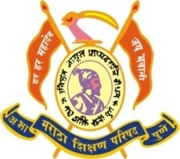 

DOI: 2/01/2023