A Seminar

On

“Name of the Seminar Topic by Student for submission TE Mech Semester II in 2019”

Submitted By

X. Y. ZZZZZ

Exam. Seat. No.: T111111111

Under the guidance of

Prof. A. B. CCCCC

Department of Mechanical Engineering

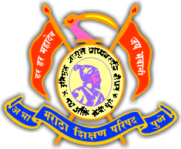 | A.B.M.S.Parishad’s  ANANTRAO PAWAR COLLEGE OF ENGINEERING & RESEARCH Parvati, Pune  [Accredited by NAAC]

[Academic Year: 2018-19]
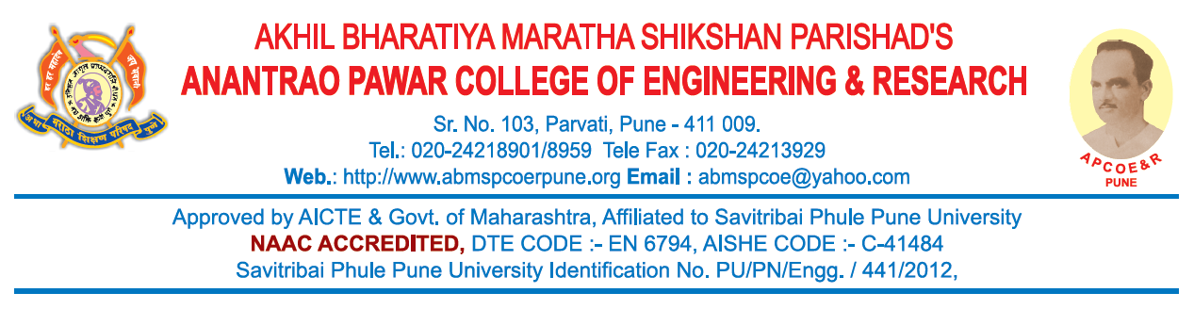
Department of Mechanical Engineering

CERTIFICATE

This is to certify that Mr / Ms _____________________________________ has successfully completed the Seminar entitled “_________________________________________________________________” under my supervision, in the partial fulfillment of Third Year of Bachelor Degree in Mechanical Engineering of Savitribai Phule Pune University.

Date: / /2019
Place: APCOE&R, Pune
Exam. Seat No.: _______________

Prof. A.B. CCCCC  Guide | Prof. G. E. Kondhalkar  Head  Mechanical Engineering Department
External Examiner | Dr. S. B. Thakare  Principal

